**SQL Assignment**

Database and Table Create:

create database Northwind

use [Northwind]

go

Create Table Products(

ProductID int Primary key NOT NULL,

ProductName varchar(50) NOT NULL,

SupplierID int NOT NULL,

CategoryID int NOT NULL,

QuantityPerUnit varchar(20) NOT NULL,

UnitPrice int NOT NULL,

UnitInStock int NOT NULL,

UnitsOnOrder int NOT NULL,

ReorderLevel int,

Discontinued bit

)

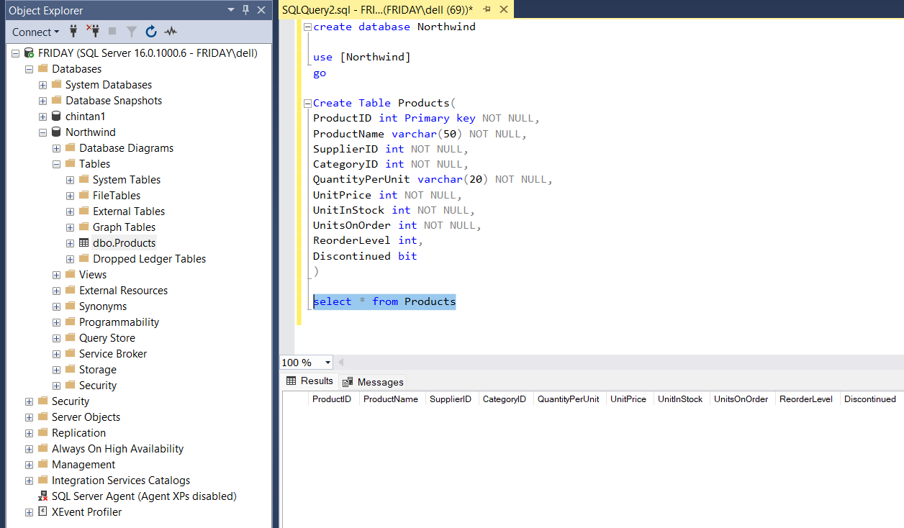

Values Inserted:

insert into Products values

(2,'Banana',2,2,'12-one pac',20,60,20,20,0),

(3,'Apple',2,2,'12-one pac',30,60,30,20,0),

(4,'salt',3,3,'200 gm-one pac',10,30,40,20,0),

(5,'Milk',3,3,'500 ml-one pac',25,10,20,50,0),

(6,'bread',3,3,'20-one pac',20,50,20,30,0),

(7,'soap',4,4,'6-one pac',20,20,5,10,0),

(8,'sugar',3,3,'500gm-one pac',15,20,10,20,0),

(9,'panner',3,3,'250 gm-one pac',35,20,15,10,0),

(10,'ghee',3,3,'500gm-one pac',50,25,10,25,1),

(11,'dittergent',4,4,'200ml-one pac',15,10,5,2,1),

(12,'butter',3,3,'100gm-one pac',50,40,20,15,0),

(13,'pen',5,3,'5-one pac',10,50,20,30,0),

(14,'books',5,3,'5-one pac',50,30,20,25,0),

(15,'waffers',3,3,'100gm-one pac',5,100,60,50,0)

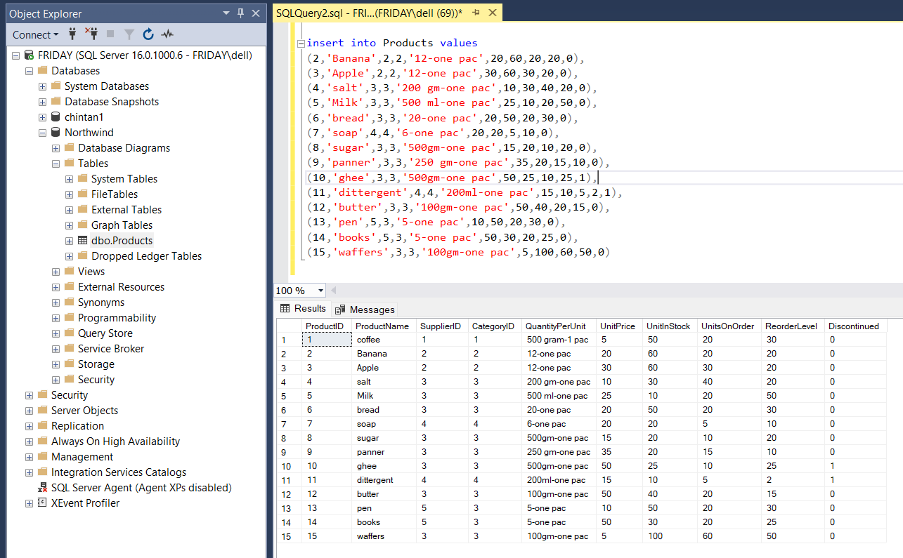

Query1: Write a query to get a Product list (id, name, unit price) where current products cost less than $20.

select ProductID,ProductName,UnitPrice from Products where UnitPrice >20

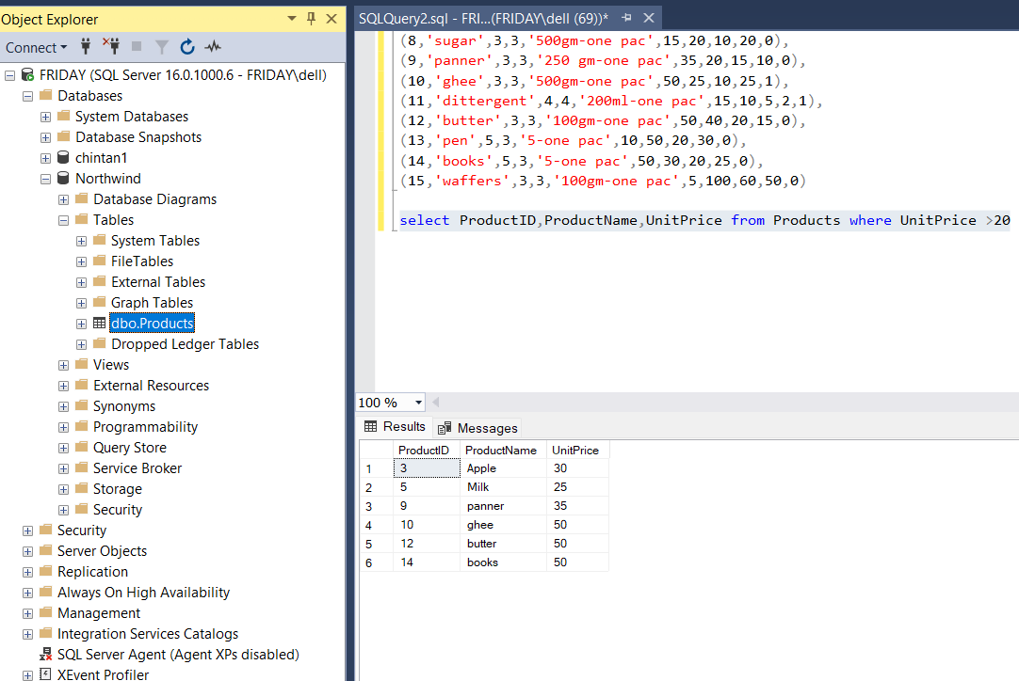

Query2: Write a query to get Product list (id, name, unit price) where products cost between $15 and $25.

select ProductID,ProductName,UnitPrice from Products where UnitPrice BETWEEN 15 AND 20

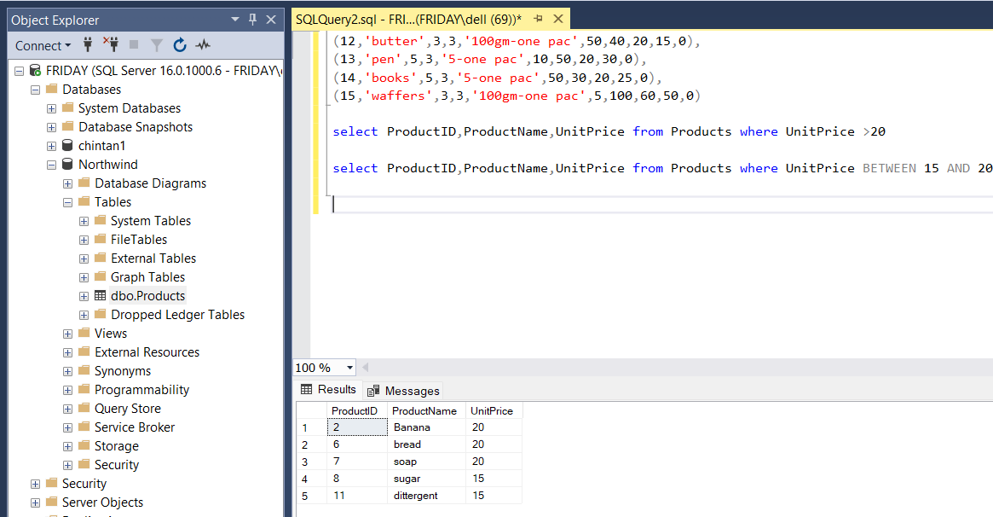

Query3: Write a query to get Product list (name, unit price) of above average price.

select ProductID,ProductName,UnitPrice from Products

where UnitPrice > (select AVG(UnitPrice) from Products)

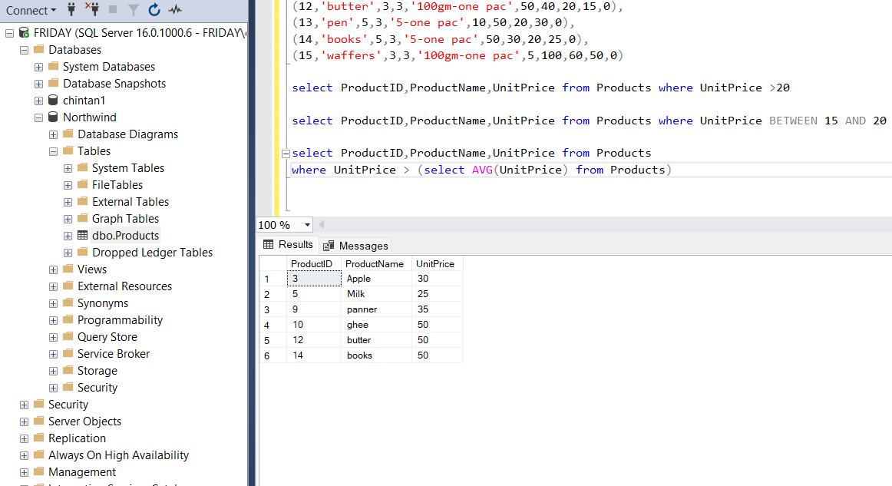

Query4: Write a query to get Product list (name, unit price) of ten most expensive products.

select top 10 ProductID,ProductName,UnitPrice from Products order by UnitPrice DESC

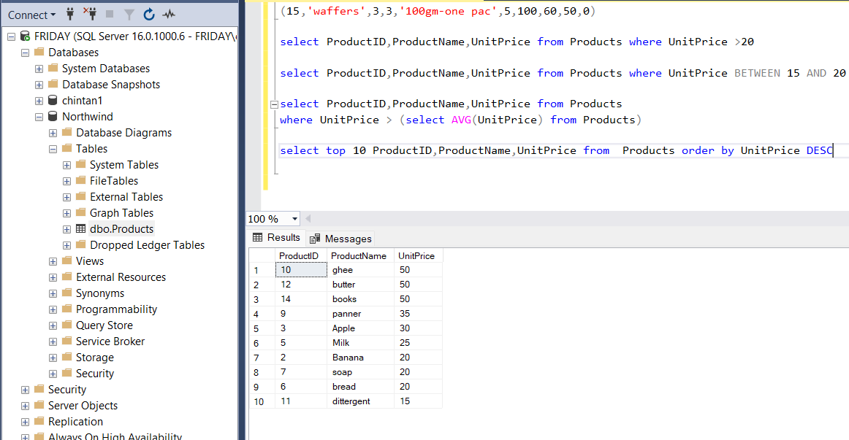

Query5: Write a query to count current and discontinued products.

select count(Discontinued) from Products group by Discontinued

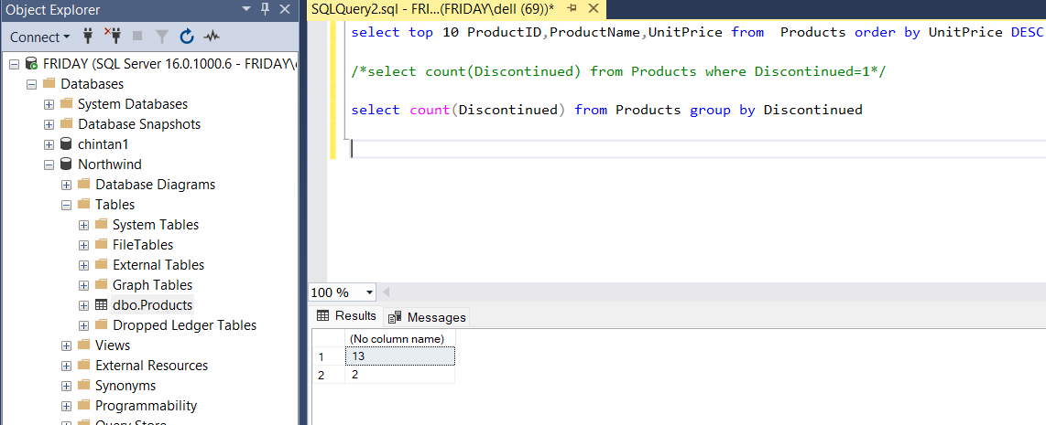

Query6: Write a query to get Product list (name, units on order , units in stock) of stock is less than the quantity on order.

select ProductName , UnitsOnOrder , UnitInStock from Products where UnitInStock < UnitsOnOrder

